Newsletter for the Parish of

Calne and Blackland

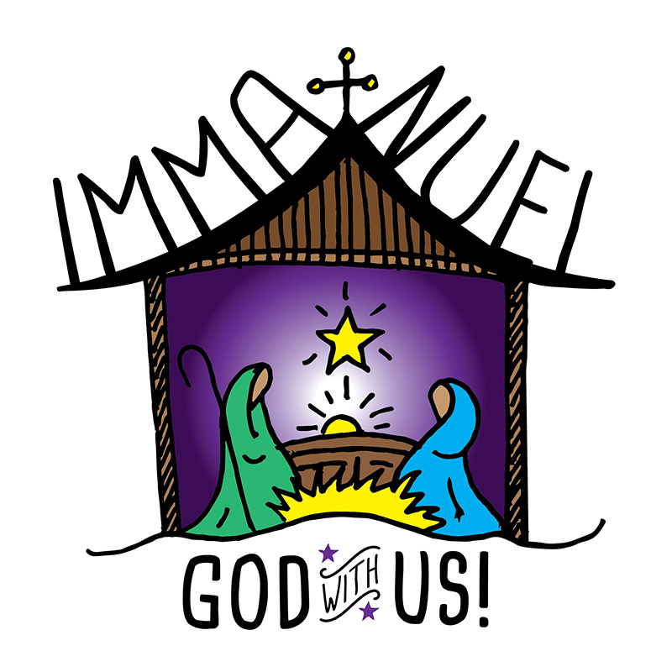

...keeping you in touch
with your church family

December 2018
Free, please take one.

Editorial Note : You will notice that the Newsletter looks a little different this month. This is because Alex Grenfell, who usually deals with layout and illustration, is unwell. We hope that he will be fit and healthy again very soon.

Parish contact details:-
Team Rector:- The Reverend Bob Kenway
Email: rakenway@gmail.com
Tel: 01249 812340

Team Vicar:- The Reverend Linda Carter
Email: lscarter@btinternet.com

Team Vicar:- The Reverend Teresa Michaux
Email: tmx256@hotmail.co.uk

Parish Administrator:- Mrs. Sadie Kenway,
Church House, 30 Church Street, Calne, SN11 0HU
Email: calnepcc@gmail.com Tel: 01249 816522
Open Tuesday to Saturday, 10:30 to 12:30

Church addresses
Holy Trinity Church, Quemerford, Calne
London Road, Calne, Wiltshire, SN11 0AR
St. Mary’s Church. Calne
Church Street, Calne, Wiltshire, SN11 0HU
St. Peter’s Church. Blackland
Blackland, Calne, Wiltshire, SN11 8UQ
Prayer of the month
May the joy of the angels, the eagerness of the shepherds,
the perseverance of the wise men, the obedience of Joseph and Mary, and the peace of the Christ-child be yours this Christmas.
Amen

THINKING POSITIVELY ABOUT ADVENT. Advent 1
“Almighty God give us grace to cast away the works of darkness and to put upon us the armour of light”.
The month of December certainly provides us with some very dark and dingy nights. The Collect reminds us though there is the darkness in this part of our world, light is coming.
Advent means’ Coming’. It particularly refers to the Second coming of Christ and the end of the world. But Advent need not be reduced to the level of an almanac, predicting what time the return of Christ will be. it is actually concerned with the maturing of the divine purpose which invites our lives, enabling us to give a full response when He comes . It is associated with the Saints who have also done the same – St Mary , St John the Baptist etc.
Real freedom lies, in our hands. If everything has been predicted then we can do nothing. But Advent says that much is in our hands -if we are to be concerned with the maturing of the divine purpose within us.
The Christian response to darkness is of course to put on the Armour of Light. We are told about this in Paul’s Letter to the Ephesians; “put on the armour of God with which you will be able to stand against the evil one”. The need for light is certainly the origin of the candles on the altar In the days when there was no gas or electricity. Candles were provided so that the priest could read the altar prayer book. But they also remind the Church that the greatest answer to spiritual darkness is Light: whether as individuals or as a community we have to have the Light of Christ,
Today Christians can stand up in the realm of honesty. You will find it suggested that honesty is always the best policy, In some social brackets tax evasion is a practice refined to an art form. But without honesty we may be stealing; who knows the number of people whose lives have been shattered by burglary .
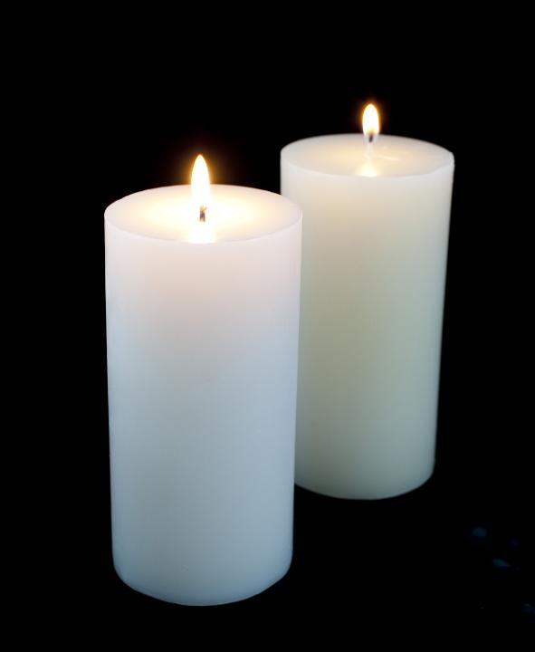Christians can stand out as light in our dark world in the area of sexual faithfulness . The Christian who resolutely holds the concept of light in the world will realise that the heart of the Christian teaching is that people must be treated as an end not a means to an end. The Heart of the Christian practice is to enable Light to shine in dark places. At Advent we remember those Christians who live with that simple honesty and sincerity.
Jeremy Cresswell
Joy to the world …
Do you have a favourite Christmas carol? There are so many to choose from : “Hark the Herald-angels sing”, “Once in Royal David city”, “Silent Night” etc. The singing of carols goes back a long way. Some carols have their origin as far back as the Middle Ages like “the Boar’s Head Carol” or “the Gloucestershire Wassail”. The word “carol” originally described a song that has a repeating chorus, and such “carols” were often sung in the context of a ring dance. These were often secular or pagan in origin, and were very popular with the people but not so with religious officials. Various church councils and synods tried to ban the singing of carols but I am glad to say without success.

It was probably St Francis who was responsible for vitalizing the Christian celebration of the birth of Christ. Early in the 13th Century he created the first (or one of the first!) life-sized Nativity scenes, complete with live animals, a real baby in the manger, and a worship service. This service included the singing of lively, joyful Christmas music—something that was unknown up to this time. Our annual Crib Service of Christmas Eve has it’s roots in this Franciscan tradition.

After the Puritans tried to ban Christmas in England in the early 17th Century the celebration of Christmas became much muted. But it was re-invigorated by the Victorians—helped along by the likes of Charles Dickens. Christmas became a popular celebration again, and drew upon traditions from the continent. It was during this same period that many of our favourite carols were either written or published for the first time.

Have you thought of a favourite carol yet? One of my own favourites is “Joy to the world”.

The words to “Joy to the world” were written by Isaac Watts in 1719 (based on words from Psalm 98) and the music by Lowell Mason composed in 1848 (ostensibly from a tune from Handel’s Messiah - though there is scholarly debate about this!).

Joy to the world! The Lord is come.
Let earth receive her king;
Let every heart prepare Him room;
And heav’n and nature sing …

Christmas seems capable of bringing out both people’s grumpy and happy sides. There’s Scrooge crying “Humbug!” at the very mention of Christmas and there’s Scrooge’s young nephew saying by contrast: “I have always thought of Christmas … as a good time: a kind, forgiving, charitable, pleasant time: the only time I know of, in the long calendar of the year, when men and women seem by one consent to open up their shut-up hearts freely”. Well said Scrooge’s nephew!

As we travel through Advent to Christmas there is only one task for each of us and that is to open up shut-up hearts or as Isaac Watts has put it “Let every heart prepare Him room”. Christmas is and should be a joy for us all (whatever our grumpiness about some aspects of the world’s approach to Christmas). For at the heart of it is the birth of a baby - in itself a reason for celebration. But this is not any baby but the birth of Jesus (God’s Messiah, the Christ, his Anointed One, his own and only Son) the one who reveals in his birth, in his life, in his death and in his resurrection the very height, depth and breadth of the love of God. It is He, God’s love incarnate, that seeks room in our hearts if we would let him in.

One of our recent parish traditions for Christmas is the Posada. It’s based on a Mexican tradition (Posada is Spanish for “Inn”). A Nativity set journeys around the parish and is given a home for the night. The host for each night pledges to take the Nativity to another home the next day. This reminds us how on the first Christmas Mary and Joseph went around Bethlehem looking for a room for a baby to be born. There was none save in an outhouse, a stable. But the question remains for us this Christmas as at every Christmas: will we make room for Jesus, not only for a night but for every day of our lives? For Jesus is a “Joy to the world”, and joy of its nature has to be shared we cannot keep it to ourselves. But we cannot make room for Jesus if we don’t also make room for each other.

May God give you his love, his peace and his joy this
Christmas. . . . and enjoy the carols! Bob Kenway
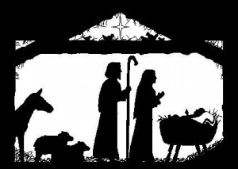

Forthcoming events in the Parish
Heart for Calne
Christians with a heart for prayer coming together in unity to pray for the town of Calne; on Saturday 8th December at 9.45 am in the Scout Hut, Quarr Barton
FOSM
Cordially invite you to an afternoon of Christmas music, TUNES & TEA,
Sunday 9th December at 3.00 pm in Marden House,Calne
Tickets £7.50 per person (including tea & cakes) from Di Nicholls or Eve Townson
Mothers Union
The Mothers Union meet on Tuesday 11th December in Church House, downstairs, at 1.50 pm for prayers followed by their meeting at 2.10 pm
when the speaker will be Rev’d Wendy Tucker, the subject ‘Advent Reflection’
December 17th Holy Trinity Academy Carol Concert
St.Mary’s Church 6.00 pm
December 18th Christingle Service
Holy Trinity Church 6.00 pm
December 19th Marden Vale Academy Carol Concert
St.Mary’s Church 10.35 am
Soup-er Lunch
Friday 21st December 12.30 to 1.30 pm in Church House.
Lunch of homemade soup, bread and cheese....
followed at 2.00 pm by CAMEO - “Come and meet us”
A special Christmas CAMEO in Marden House
Sunday December 23rd
St. Mary’s - 8.00 am Holy Communion 10.00 Parish Eucharist
6.00 pm Carols by Candlelight
Holy Trinity - 9.15 am Family Service 10.45 Carol Service
St.Peter’s - 3.00 pm Carol Service
Monday December 24th
St. Mary’s - 4.00 pm Crib Service 11.30 pm Midnight Mass
Tuesday December 25th
St. Mary’s – 8.00 am Holy Communion 10.00 Parish Eucharist
Holy Trinity - 10.45 am Holy Communion
St.Peter’s - 9.30 am Holy Communion
Sunday December 30th
St. Mary’s - 8.00 am Holy Communion 10.00 United Benefice Eucharist
30 Years of Ride and Stride
Editorial Team:-
Jack Robinson, Sue Twyman and Jane Ridgwell.
Illustration, computer design and Layout:- Alexander S. Grenfell
And finally...

If you organise any groups or events in the parish and would like them to be included
in this newsletter then get in touch with the editors.
We would also love to have articles about the different groups in the parish to spread
the word more widely and encourage people to come along.
Please Email or give copies of items to us in plenty of time for the next newsletter, the
deadline is 10th of the preceding month.

Email: cbp.news.editor@gmail.com.
When I first rode in 1989 it was known as the Great Sponsored Cycle Ride. I had moved to Calne with my wife and daughters the year before. I had just restarted cycling after decades of not being a member of a cycling club and had joined the Chippenham Wheelers.
In 2007 it was being described as a Sponsored Ride and Stride – The Great Cycle Ride. Later it became known as Ride and Stride. It has always been held on the second Saturday in September. From my records I have taken part every year. It has always lasted 8 hours from 10am to 6pm. The greatest number of churches that I have visited was 37 in 1996 and I must have covered over 70 miles. Once or twice, in the early years my wife, Jackie, joined me for 10 or 15 miles. I have always tried to be near home by 6pm, but I am often at least 7 miles away.
The older I get the more I try to avoid climbing the steeper hills, but still enjoy a fast descent! This year I visited 26 churches including Calne, Cherhill, Clyffe Pypard, Broad Town, Royal Wootton Bassett, Kellaways and Draycot Cerne, having covered about 60 miles by the time I got home.
In 1989 I raised only £25, this year I expect to raise over £400. Over the 30 year period, just on Ride and Stride I have cycled the equivalent of Lands End to John O’Groats and back again. A big thank you to all those who have sponsored me over the years. The proceeds of my rides are divided between Wiltshire Historic Churches Trust and the Parish of Calne and Blackland
Stan Anniss
Regular Activities in the parish

Day | Time | Place | Activity
Sunday | 8:00am | St. Mary’s | Holy Communion
 | 9.30am | St. Peter’s | Family service - Second Sunday of the month  Holy Communion other Sundays
 | 9:15am | Holy Trinity | Family service - First Sunday of the month only.
 | 10:00am | St. Mary’s | Parish Eucharist
 | 10:45am | Holy Trinity | Morning Prayer – First Sunday of the month.  Holy Communion other Sundays
 | 3:00pm | Holy Trinity Academy | Messy Church – twice a term - check notices for dates.
Tuesday | 10:00am | Church House | SMUFs parent and toddler group.  NOTE only during term time.
 | 6:30pm to  7:00pm | Various | Parish Prayers – check notices for location
Wednesday | 10:00am | St. Mary’s | Holy Communion (Mothers’  Union corporate Service first  Wednesday of the mouth).
Thursday | 2.30pm to  4.00pm  6.30-7pm | Church House  St Mary’s | Cuppa and Company  Christian Meditation
Friday | 12:00pm | St. Mary’s | Holy Communion
 | 2:00pm | Church House | CAMEO – Come And Meet Each Other.  NOTE only 3rd Friday of the month
 | 7:00pm | St. Mary’s | Choir practice
 | 7.30pm | St Mary’s | Bell ringing practice
Saturday | 9am | Various | Men’s Breakfast. (1st Sat)
For more information please see
www.parishofcalneandblackland.org.uk/

